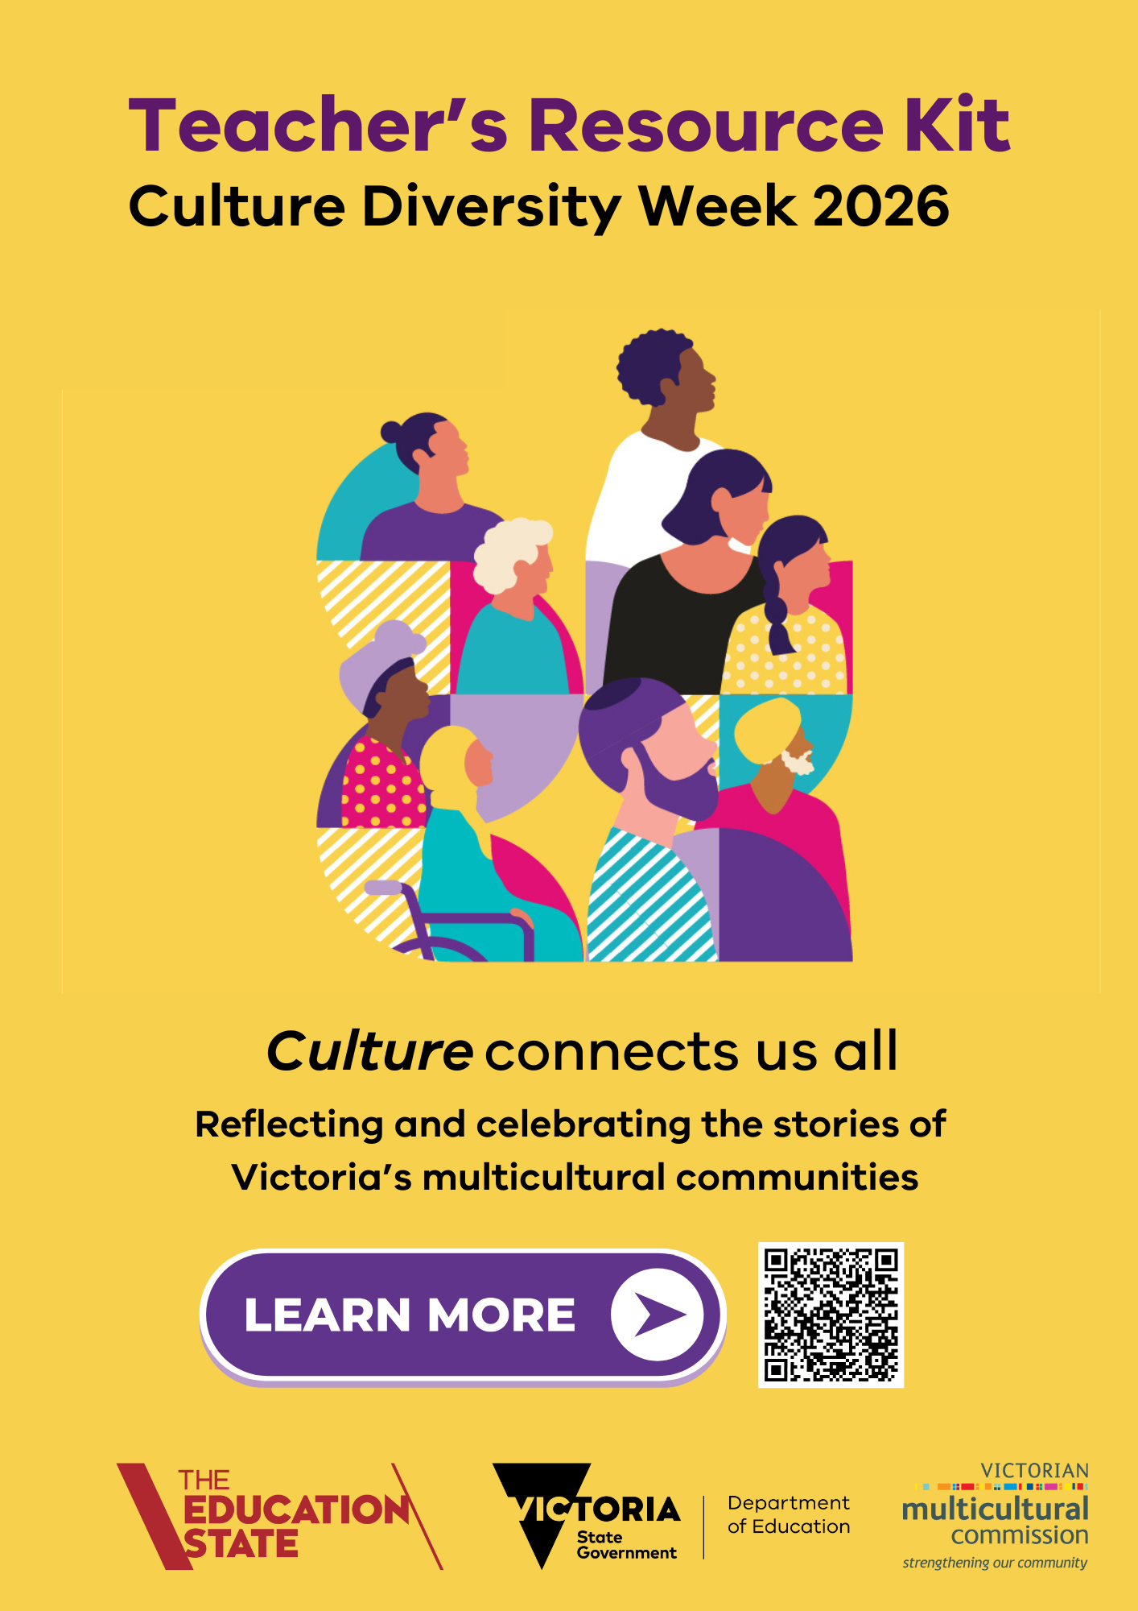
Table of contents

Message from the VMC Chairperson 3

Acknowledgement of Country 4

About Cultural Diversity Week 5

2026 Cultural Diversity Week 6

About the Victorian Multicultural Commission 7

About the Teacher’s Resource Kit 8

Student competition 9

2026 Ideas for schools .10

Additional resources for teachers 21

Other sources 22

Message from the VMC Chairperson
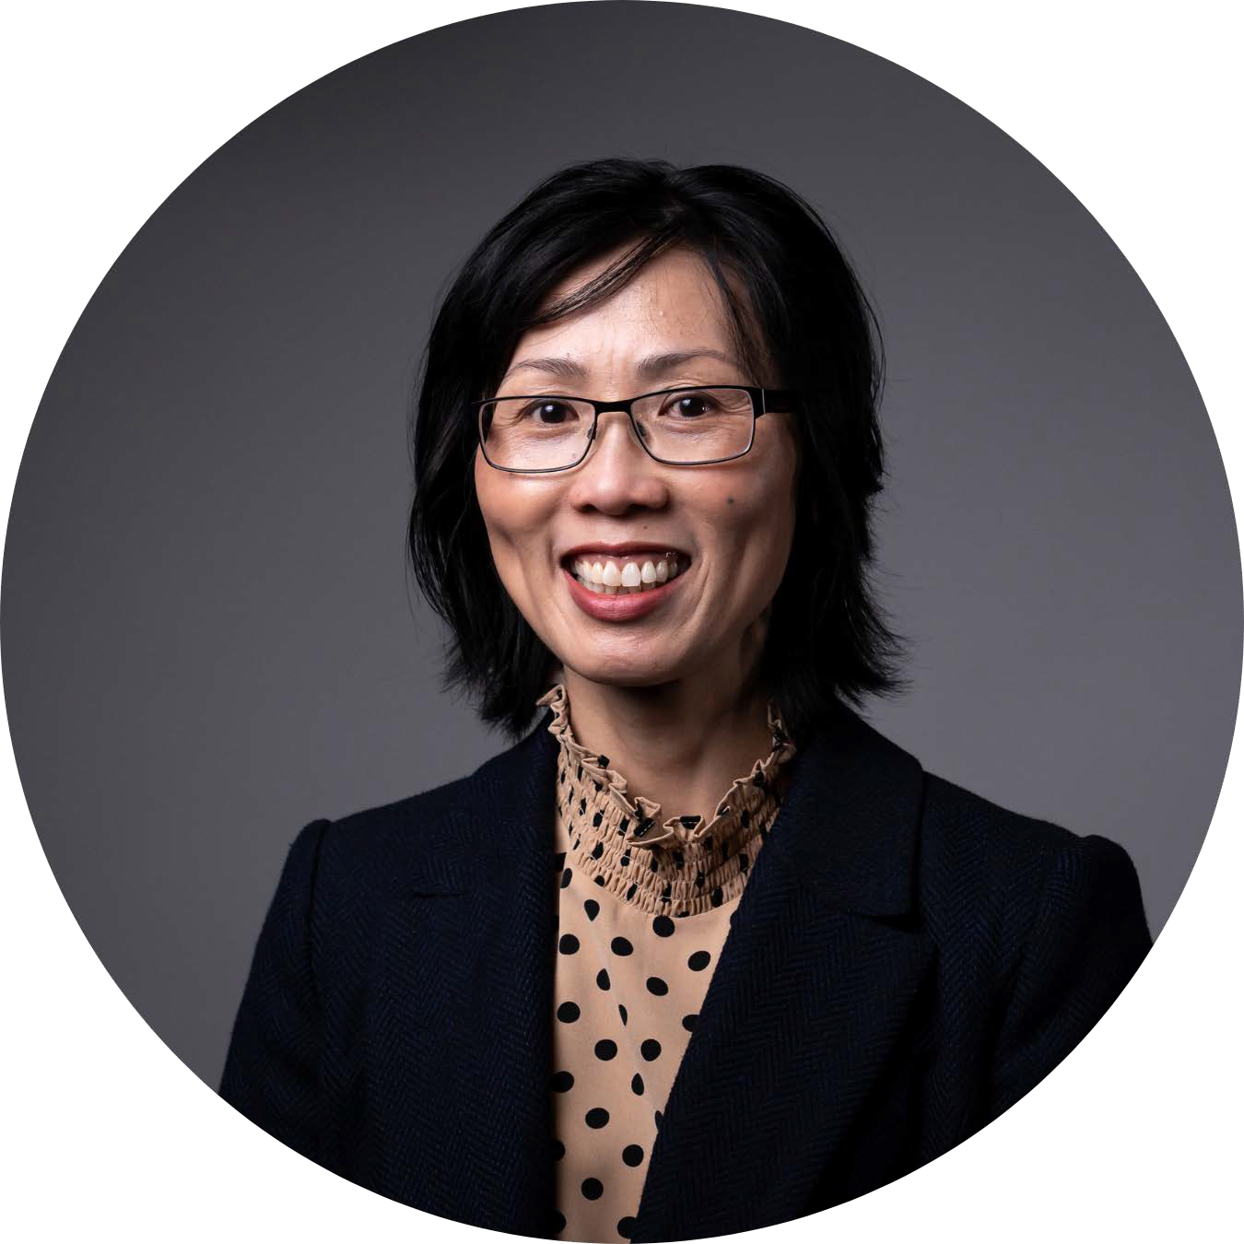
As March approaches, I am pleased to welcome the return of Cultural Diversity Week, an important moment to reflect on who we are and how we connect. From 21 to 29 March, we come together under this year’s theme, Culture connects us all, a reminder that our shared humanity is strengthened through understanding, respect and belonging.
Victoria’s cultural diversity is reflected every day in our classrooms, where students bring rich stories, traditions and perspectives that shape learning and community life. With more than 300 ancestries and nearly 290 languages represented across our state, diversity is not only part of our identity, but also one of our greatest strengths.
Teachers play a vital role in fostering connection, curiosity and empathy. Cultural Diversity Week offers a meaningful opportunity to explore these values with students and to celebrate both what makes us unique and what unites us.
To support this work, the Victorian Multicultural Commission is proud to present the 2026 Cultural Diversity Week Teacher’s Resource Kit, developed in partnership with the Department of Education. The Kit is designed to support inclusive classroom learning and bring the theme to life across year levels and settings.
I thank teachers across Victoria for your continued leadership in creating welcoming and inclusive learning environments. Your work helps shape a future generation that values diversity and shared responsibility.
As we mark Cultural Diversity Week, I encourage you and your students to honour the stories that define us and the connections that bring us together. Together, we continue to build a Victoria that is inclusive, respectful and enriched by its diversity.
Warm regards,

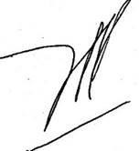

Vivienne Nguyen AM
Chairperson
Victorian Multicultural Commission

Acknowledgement of Country

The VMC acknowledges the Traditional Custodians of Country throughout Australia and pays respect to them, their culture, and Elders past and present.
​
We recognise their continuing connection to land, waters, and culture, and we honour their invaluable contributions to the rich cultural diversity of Victoria.

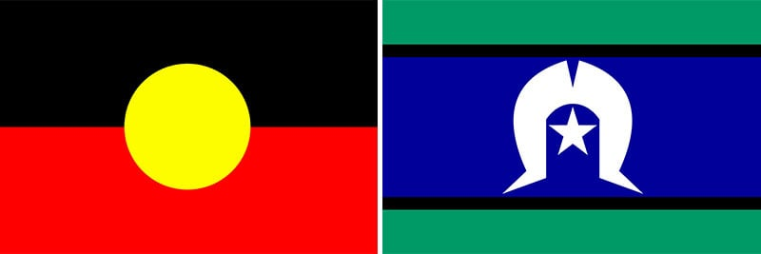

About Cultural Diversity Week
Victoria’s annual Cultural Diversity Week (CDW), led by the Victorian Multicultural Commission (VMC), celebrates cultural diversity and is centred on the United Nation’s Day for the Elimination of Racial Discrimination. Cultural Diversity Week 2026 will run from 21 to 29 March throughout Victoria. CDW is a great opportunity to highlight and celebrate the cultures within and around your school by hosting events or focusing the week’s activities on intercultural capability.
CDW focuses on Victorians with a migrant, refugee or asylum seeker background. First Nations People are an important part of cultural diversity and are Australia’s – and the world’s – oldest culture. Celebrations and acknowledgements of Aboriginal and Torres Strait Islander culture should be run throughout the year, particularly in NAIDOC Week and can be part of a school’s CDW activities.
The 2026 dates for CDW were chosen to coincide with the United Nations Day for the Elimination of Racial Discrimination on 21 March, while allowing for the strongest participation among Muslim Victorians, who expect to observe Ramadan from around 16 February to 18 March.
Cultural Diversity Week coincides with Shaheed Day, on 23 March, commemorated in Bangladesh in memory of Dhaka University students who advocated to keep Bengali as the national language. Cultural and religious observances enrich our collective celebration of diversity and inclusion. It’s important to acknowledge significant observances while celebrating CDW. We encourage educators to consider the timing of events to ensure their CDW activities are respectful and inclusive of all cultures and faiths.
As a Victorian initiative, we encourage Victorian schools to participate in CDW and use this kit’s Victorian-specific resources, in addition to the valuable resources available through the Harmony Week and Taste of Harmony campaigns, both referenced in this Kit.
We recognise that the Australian Government’s Harmony Week – 16 to 22 March 2026 – which often has a particular focus on schools, will occur prior to our state wide campaign. We note, too, the Scanlon Foundation’s Taste of Harmony from 19 March to 18 April 2026, which focuses on workplaces. CDW encourages schools, workplaces and community groups, places of worship, businesses, and state and local government, to participate in all these events.

2026 Cultural Diversity Week

Cultural Diversity Week will run from 21 to 29 March 2026 in Victoria. The 2026 CDW theme is Culture connects us all.
The theme highlights how sharing intercultural stories and experiences fosters understanding, belonging and connection.
The theme will be used by organisations and businesses to guide their CDW events and celebrations. We encourage teachers to do the same, and to thread this theme throughout discussions and activities. 2026 branded digital resources are available on the VMC’s Cultural Diversity Week 2026 website. These include:
- an email signature banner and header

- social media tiles
- PowerPoint template
- MS word template
- posters
- virtual background for online meetings

About the Victorian Multicultural Commission
The VMC was established as a statutory body in 1983 and is constituted under the Multicultural Victoria Act 2011. In 2023, the VMC celebrated its 40-year anniversary. Read highlights in the VMC 40th Year Anniversary Report.

We strengthen our community through support, celebrations and advocacy for culturally and linguistically diverse Victorians.

The VMC is dedicated to:
- promoting cultural diversity across all areas of society
- advocating on behalf of multicultural communities to all levels of government
- full participation by all Victorians regardless of their cultural, linguistic and religious backgrounds.
Acting as a vital conduit between culturally, religiously and linguistically diverse communities and the Victorian Government, the VMC fosters social cohesion in Victoria, and promotes cultural diversity, through a strengths-based approach and by empowering community-based solutions.
The VMC connects multicultural communities with government (and government with community) by engaging directly with people to understand issues. We work together to identify and recommend potential solutions to government, policy makers and community organisations to make public services more inclusive and accessible for culturally diverse Victorians.
Learn more about us by reading our 2024 – 2025 Annual Report.

About the Teacher’s Resource Kit
Victoria is a proudly multicultural state. Victorians come from more than 300 ancestries, speak 290 languages and follow almost 200 different faiths. Cultural, linguistic and faith-based diversity is one of our greatest assets.

Schools play a critical role in strengthening cultural inclusion in our community. They provide an environment where acceptance of diversity, knowledge of other cultures and understanding of global and local issues are developed and are part of everyday life.

By providing safe, inclusive and welcoming classrooms, teachers help students feel a sense of belonging and connection to their school, community and to Victoria.
This kit is designed to provide inspiration and assistance to help your school celebrate cultural diversity in the classroom. We’ve included links to curriculum resources, ideas for classroom discussion and other activities to undertake during CDW.
This kit is available online at VMC’s 2026 Cultural Diversity Week website.

Student competition

Collaborate with your classroom to enter the CDW competition celebrating the theme, Culture connects us all.
Discover cultures through relationships!
Students are encouraged to interview a classmate (or family member) about their culture, traditions or favourite cultural food, then present what they’ve learned through a creative medium such as a poster, drawing, collage, craft, song or short story.
To enter the competition, teachers are encouraged to submit student work or a
collage of a class project celebrating intercultural exchanges by emailing communications@vmc.vic.gov.au For privacy and child safety reasons, please do not submit photographs of children or anything that may identify children.
Schools will need to seek consent from the parent or guardian, as per their usual communications process or platform, prior to entering. If a student is submitting artwork that relates to another student, consent must also be sought from the other student’s parents or guardian.

The deadline is Wednesday 18 March 2026.

Students are also welcome to enter the competition directly via their guardian.

One winner will be selected in each of the two categories:
- Primary school students
- Secondary school students
Prizes include a Diversity & Culture Book Pack and free entry to attend the Victorian Multicultural Festival to be held at Grazeland in Spotswood from 27 to 29 March 2026.
Shortlisted works from students will be showcased at the Victorian Multicultural Festival and promoted on the VMC’s digital channels. Schools or student entrants are welcome to opt-out of these opportunities should they wish to remain anonymous.

This initiative aligns with the guidance in the Victorian Government Department of
Education’s Preventing and Addressing Racism in Schools policy, so feel free to incorporate this competition into existing activities your school may already have planned for Cultural Diversity Week or Harmony Week.

For further information on privacy and the terms and conditions to enter the student competition, visit: https://www.multiculturalcommission.vic.gov.au/cdw-student-competition-terms-and-conditions

2026 Ideas for schools

The 2026 CDW theme is Culture connects us all.

Schools are invited to reflect on the many cultures and communities that have shaped Victoria in the past and to look to the future of Victoria as a multicultural state.

The following ideas, activities and lesson plans can help to guide classroom discussion and whole-of-school engagement in celebrating CDW.
Celebrating cultural diversity
Values, civics, citizenship and religious education
Lesson Ideas
Acknowledgement of Country: What is the difference between an ‘Acknowledgement of Country’ and a ‘Welcome to Country’? Develop an ‘Acknowledgment of Country’ that can be used at your school.
Class collage: Make a collage that represents the diversity of your class. Be open to the many different ways of doing this.
Colours in cultures: Make a list of colours. Ask people from a variety of different cultural backgrounds what each colour represents in their culture of origin.
Connection and belonging: Why is it important to feel like you belong? What might make someone feel like they don’t belong? What can we do to help a person feel like they belong?
Cultural Diversity Week banner: Create a banner to promote Cultural Diversity Week and display it where parents and community can see it.
Cultural Diversity Week promotion: Explore the purpose of Cultural Diversity Week. Create and film a promotion for Cultural Diversity Week.
Everyone Belongs logo: Design a logo that shows that everyone belongs in your school, community or country.
Family diversity: Give a talk about the people in your family and their heritage. How do they differ from each other?
Indigenous welcome: Ask an Elder from the local Indigenous people to come to your school to do a ‘Welcome to Country’ ceremony and/or visit your classroom.
My cultural identity: Share how your cultural heritage and identity is expressed. For example, birthdays, holidays or other important times, special foods, music or prayers.
My family: What stories and traditions did you grow up with? What values did those stories teach you?
My groups: List all the groups to which you belong e.g. team, family, friendship group, hobby.
Our school and community: What are our differences? What similarities do we share? How can we celebrate diversity in our community?
Places of worship: Find out how many different places of worship there are in your community. Who worships there?
Preventing and responding to racism: Explore the Schools Standing Up to Racism resources and discuss what ‘antiracism’ means to you.
Show and tell: Bring an item or photo from home that has special cultural significance for you. Share the story of the item, explaining why it is important for your family or culture. Photos could be displayed in an exhibition or classroom wall.
Student leaders: Use the Student Leaders for Multicultural Inclusion resource to empower students take the lead on identifying opportunities and implementing ideas to strengthen intercultural understanding and celebrate cultural diversity in your school.
What is diversity? What are some of the ways that people can be different from each other? What things make us the same?
Lesson Plans
Anh’s story: See life through Anh’s story. Explore three detailed activities ‘Understanding Anh’, ‘Many Stories museum’ and ‘Seeing ourselves’. Experience an interactive way of learning!
Kofi’s story: Unravel Kofi’s story and explore three detailed activities ‘The Power of symbols’, ‘Refugees in Australia’ and ‘Everyone can be a lifesaver’. Experience an interactive way of learning!
Discuss it: A useful way to stimulate discussion on a range of cultural diversity issues and develop constructive discussion skills.
Stereotypes: A role play style activity that explores the concept of stereotypes and the assumptions that underlie them.
Popular culture and diversity: Students explore themes of cultural diversity through the lyrics of popular songs.
Our diverse classroom: Students build relationships through the exploration of the diverse backgrounds and experiences of their classmates.
Listen in: Prepares students to use effective listening and questioning skills during a visit from a guest speaker from another culture.
My family and community: Ask students to speak to their family members or guardians to research and present their findings on their family’s arrival or history in Australia.

Multicultural Australia: Ask students to research and present their findings on:
- the history of multiculturalism in Victoria and Australia
- stories of people with refugee, asylum seeker or migrant backgrounds, and their settlement in, and contribution to, Victoria and Australia
- the comparison between multiculturalism in Australia and other countries, such as Canada, New Zealand, Japan or Germany.
Activities
Diversity challenges chatterbox (287.6 kB)
Crossword
- Crossword (284 kB)
- Crossword solution (142.9 kB)
Discussion dice – Sporting teams: To develop the students’ awareness that sport contributes to a better understanding of the diverse cultures in Australia.
Discussion dice – Sporting teams (231.4 kB)
Discussion dice – Origins of sport: To develop the students’ awareness of how sport contributes to a better understanding of the diverse cultures in Australia.
Discussion dice – Origins of sport (267 kB)
Discussion dice – International Food: Using the dice, students learn that Australian food is influenced by other cultures.
Discussion dice – International Food (214.5 kB)
English
Lesson Ideas
Acrostic poem: Brainstorm some words associated with cultural diversity in Australia and choose one to write an acrostic poem.
Book review: Write a book review of a text which has diversity as a theme.
Debate: ‘Variety is the spice of life’.
Film festival: Watch films available from the previous Multicultural Film Festivals on the VMC's YouTube channel including those made by students.
Oral presentation: Give a short presentation about an Australian you admire, who has a different cultural background to your own.
Oral presentation: Give a short presentation about a person who has made a positive contribution, directly or indirectly, to promoting diversity in Australia.
My books: List the books that you have read in the last six months. Do any of these books explore (through characters or themes) a culture different to your own?
Popular culture: Select a form of popular culture e.g. cartoons, graffiti. Compare and contrast examples of this genre and how it is expressed in different cultures.
The power of words: Select a media item which focuses on race, ethnicity or religion. Identify any emotive words and phrases. Replace these with less emotive language. Does this change the message?
Two sides to every story: Write a short account of an event from two different points of view.
What’s in a name? Research the cultural origins of your first and last names. Do they have a meaning or story? Are there variations of your name in other languages e.g. John/Ivan/Giovanni/Johann?
Word challenge: How many words with three letters or more can you make from the letters in the words ‘Celebrate Australia’s Diversity’?
Activities
Acrostic puzzle
- Acrostic puzzle one (127.9 kB)
- Acrostic solution one (142.7 kB)
- Acrostic puzzle two (139.9 kB)
- Acrostic solution two (126.4 kB)
Crossword
- Crossword (284 kB)
- Crossword solution (142.9 kB)

Languages
Lesson Ideas
Body language: Ask schoolmates from various cultural backgrounds what gestures they would use to show the following: ‘Come here’, ‘Go away’, ‘I don’t know’, ‘OK’, ‘Good’, ‘Yes’, ‘No’.

Borrowed words: Compile a list of words commonly used in English that have been borrowed from other languages.
Debate: ‘All Australian students should study a second language throughout their schooling’.
Diverse scripts: Can any of your classmates write in another script (e.g. Korean, Arabic)? Ask them to teach you how to write a word in this script.
Linguists: Find out how many people in your class/school are bilingual or multilingual. Graph your findings.
Many languages: Conduct a survey to identify languages that are spoken in your school or local community. Graph the results.
Language treasure hunt: Use your schoolmates as a resource to ‘collect’ basic words or expressions in other languages.
Religion and language: Research and graph the religions practised by people across the world who speak the language you are studying.
Roll call: Say ‘good morning/afternoon’ in a different language each week.
Simple phrases: Learn and share with your class simple phrases like 'hello' and 'thank you' in different languages with these sound recordings.
What’s in a name? Research the cultural origins of your first and last names. Do they have a meaning or story? Are there variations of your name in other languages e.g. John/Ivan/Giovanni/Johann?
Words in common: Identify words from the language you are studying that are also used in English language conversations e.g. faux pas, kamikaze.

Arts
Lesson Ideas
Aussie art: investigate some of the many techniques used by Australian artists that have been drawn from different cultures e.g. dot painting, batik, mosaics, papier mache, origami etc.
Building designs: Look at local buildings to find design features that have been inspired by different cultures/religions.
Class collage: Make a collage that represents the diversity of your class. Be open to the many different ways of doing this.
Colour of culture: Find out what meaning or significance colours have in different cultures. Create a design in one colour reflecting what that colour means in a particular culture.
Cultural Diversity Week banner: Create a banner to promote Cultural Diversity Week and display it where parents and community can see it.
Diverse dancing: Have members of the class demonstrate a dance they have learned. Teach some of the steps to classmates.
Everyone Belongs logo: Design a logo that shows that everyone belongs in your school, community or country.
Fashion designers: Research some Australian fashion designers. What is their background? Does it influence their designs?
Film festival: Watch films available from MFF 2025 and previous Multicultural Film Festivals on the VMC's YouTube channel including those made by students.
Movement to music: Listen to a diversity of music styles and represent what you hear through movement.
Musical tastes: Bring a piece of music that one of your parents likes and play it for the class. What are its origins.
Painting to music: Listen to a diversity of music styles and represent what you hear with different colours and brushstrokes to create an abstract piece.
Self-portrait: Mix paint to match, as closely as possible, the colour of your skin, hair and eyes. Paint a picture of your face aiming for realism in portraying your features.
Lesson Plans
Popular culture and diversity: Students explore themes of cultural diversity through the lyrics of popular songs.
Body decorations: Students learn why people from a range of cultures decorate their bodies and are introduced to Indian (Hindu) customs of henna hand painting.
Marvellous mosaics: Familiarises students with mosaic art as found in Muslim mosques and other cultural buildings.

Science
Lesson Ideas
Aussie scientists: Research some famous Australian scientists and their backgrounds.
Bridging technology: Investigate how technology can help to bring people together and break down barriers.
Diverse nature: Look at ways that diversity exists and functions in ecosystems e.g. coral reef, rainforest, desert.

Fauna: Investigate the birds, insects and other animals you see around your school. How many are native to Australia? Where did the others come from?
Flora: Investigate the trees and plants in your school. How many are native to Australia? Where did the others come from?
Herb garden: Establish a class herb garden. What type of cuisine is each herb associated with? Use the herbs to prepare a dish e.g. herb bread.
Indigenous technology: Examine the scientific principles underlying traditional Australian Indigenous technologies e.g. boomerangs/flight.
Necessity is the mother of invention: Find examples of where cultural practice or religious need has been the catalyst for invention e.g. the Islamic practice of washing before prayer was a catalyst for the invention of soap.

History
Lesson Ideas
Class museum: Create a museum of family objects, reflecting the diversity of the students in your class.
Family diversity: Give a talk about the people in your family and their heritage. How do they differ from each other?
Indigenous welcome: Ask an Elder from the local Indigenous people to come to your school to do a ‘Welcome to Country’ ceremony and/or visit your classroom.
Local Indigenous Country: Find out the name of the traditional Indigenous custodians of the land on which your school is built. Include an ‘Acknowledgement of Country’ statement in your daily class routine.
Songs in history: Collect the lyrics of songs that have been popular in Australia at different times over the last 100 years. How does each song portray diversity in Australian society at the time?
Two sides to every story: Write a short account of an event from two different points of view.
Lesson Plans
Driven out: This is a short activity which can serve as an introduction to the issues that refugees and migrants can face.

Geography
Architects: Research some Australian architects, or architects who have designed famous Australian buildings. What is their background? Does it influence their designs?
Connection to Country: Explore Indigenous Australian spirituality regarding connection to land. How does this differ from non-Indigenous notions of relationship to land? What impact did these beliefs have during the colonisation of Australia?
This map of Traditional Owners with land divisions and language groups shows the diversity of First Nations cultures across Australia.
Globalisation of English: How has the dominance of the English language impacted on diversity in the world today?
Flora: Investigate the trees and plants in your school. How many are native to Australia? Where did the others come from?
Mapping the land: Look at some Indigenous Australian paintings of the land. How do they show landforms and other natural features? How are the same features identified on contemporary contour maps?
Pets: What breed of dog/cat/other pet do you have, or would you like? In what country did that breed originate?
Places of worship: Find out how many different places of worship there are in your community. Who worships there?
Stats and facts: Use the statistics from the latest Census (the Australian Bureau of Statistics) to find out some key information about Australia’s population e.g. most commonly spoken languages other than English, countries of birth. Compare these with your own area.
Lesson Plans
Body decorations: Students learn why people from a range of cultures decorate their bodies and are introduced to Indian (Hindu) customs of henna hand painting.
Marvellous mosaics: Familiarises students with mosaic art as found in Muslim mosques and other cultural buildings.
Our diverse classroom: Students build relationships through the exploration of the diverse backgrounds and experiences of their classmates.
Discuss it: A useful way to stimulate discussion on a range of cultural diversity issues and develop constructive discussion skills.
Culture, race and ethnicity: Students are introduced to these concepts and how they differ from each other, then apply them to their own experiences.

Activities
Discussion dice – Geography: To introduce countries around the world and to make connections to cultural identity
Discussion dice – Geography (278.9 kB)
Driven out: This is a short activity which can serve as an introduction to the issues that refugees and migrants can face.

Health and physical education
Lesson Ideas
24-hour menu: List all the foods that you have eaten in the last 24 hours. What are the origins of each dish you have eaten?
Alternative therapies: Identify some of the alternative medical or health therapies in Australia. Where did they originate?
Aussie sports: What sports are played in Australia? Where did they originate?
Dinner last night: Do a survey of what everyone in your class had for dinner last night. Investigate the origins of all the dishes.
Food alphabet: Using each letter in the alphabet as a first letter, make a list of foods available in Australia. Find out where each food came from.
International sports: What sports are played in different regions/countries of the world?
Relax: Try some methods of relaxation that are practised in Australia (e.g. Tai Chi, yoga, meditation). What is their origin?
Sporting Aussies: Does sport play a role in promoting an inclusive and harmonious community?
Teammates: Choose an Australian sporting team. Research the heritage of each team member.
Lesson Plans
Stereotypes: A role play style activity that explores the concept of stereotypes and the assumptions that underlie them.

Mathematics
Lesson Ideas
Bilingual counting: Ask a bilingual classmate to teach you how to count to 10 in their other language.
Diverse symbols: Ask your parents to write down the symbols they learned as children for the four basic maths operations. Compare them with your classmates. Are there any differences?
Magnificent mathematicians: Identify leading mathematicians from different times and cultures. What have their contributions to mathematics been?
School stats: Conduct a survey and develop some statistics about your school student population. Display them for everyone to see, or include them in the newsletter.
Stats and facts: Use the statistics from the latest Census (the Australian Bureau of Statistics) to find out some key information about Australia’s population e.g. most commonly spoken languages other than English, countries of birth. Compare these with your own area.
Survey and graph: Design, develop and implement a survey to measure diversity in your school community. Analyse and graph your results.
Tessellations: What is tessellation? Find examples of tessellation from buildings reflecting different cultural and religious heritages in Australia.

Beyond the classroom
Incursions
Invite a VMC Commissioner, local author or community leader from Victoria’s multicultural community to speak or present at your school. Suggested topics:
- the importance of cultural diversity to Victoria’s past, present and future
- how cultural diversity has evolved throughout Victoria’s history
- the challenges and benefits of living and working in a culturally diverse state and country
- the speaker’s cultural identity and the story of how they came to live in Australia
Invite a Refugee Ambassador to speak or present at your school. Refugee Stories for Change helps young people understand and empathise with the refugee journey and understand the contribution refugees are making in our societies.
The Vietnamese Museum Australia (currently being built) has education programs sending representatives to schools to specifically speak about the Vietnamese refugee journey.
Excursions
The Immigration Museum: Plan an excursion to Melbourne’s Immigration Museum or use their range of school programs and resources.
Cultural museums: Plan an excursion to one of Victoria’s Multicultural Museums, such as the Hellenic Museum, Museum of Chinese Australian History, Islamic Museum of Australia, Jewish Museum of Australia or CO.AS.IT Museo Italiano.
Involve your school community
Host a performance: Organise a performance at assembly for students to demonstrate traditional dance, songs, or crafts.
Share a meal: Organise a shared morning tea or lunch. The Taste of Harmony website has a range of resources, including recipes that you could cook at school.
Host a lunch: Organise a catered lunch from social enterprises that support Victorians who arrived as a refugee or asylum seeker. For example:
- Free to Feed
- Asylum Seeker Resource Centre

Additional resources for teachers

Victorian Department of Education (DE)
- Multicultural Education Programs and Resources
- Languages and Multicultural Education Resource Centre (LMERC) – a specialised library providing resources and advice to support the fields of Languages, English as an Additional Language, Multicultural Education and the cross-curriculum priority areas and capabilities. Their catalogue includes curated lists for culturally diverse text selection and to support the intercultural capability.
- Koorie Teaching Resources
- Indigenous cross cultural training resources
- Annual Events – celebrating cultural diversity
- ARC: Intercultural Capability resources
- Bully Stoppers: Racist Bullying
- Poster - Speaking in home language is the best way to help your child succeed
- Preventing and Addressing Racism in Schools policy, supports schools to strengthen their culture and practice to address racism, religious intolerance and racial and religious vilification – includes guidance and resources.
- Student Leaders for Multicultural Inclusion guide – a comprehensive resource with activities designed for Victorian schools based on the Framework for Improving Student Outcomes (FISO 2.0)
- Workforce diversity and inclusion training for school staff
- Supporting students from refugee backgrounds, including targeted programs delivered in schools by Foundation House and the Centre for Multicultural Youth

Victorian Curriculum Assessment Authority (VCAA)
  - Intercultural Capability - Introduction and Curriculum
  - Intercultural Capabilities - Find a teaching resource
  - Teacher Guide- Navigating intercultural issues in the classroom
  - Poster- How do we talk about culture in the classroom
  - Victorian Aboriginal Languages
  - Civics and Citizenship – Student-led classroom resources

Resources for providing cultural safety for First Nations students
- Indigenous cultural responsiveness self-reflection tool
- Guide to evaluating and selecting education resources
- Building Aboriginal cultural competency and safety training for organisations
- Australian Institute of Aboriginal and Torres Strait Islander Studies (AIATSIS), Core Cultural Learning – an online course developed to strengthen an organisation’s cultural capability
- For advice to schools about how to establish and maintain culturally inclusive learning environments, see Koorie Education Workforce (KEW), the Victorian Aboriginal Education Association Inc. (VAEAI) and the PROTECT guidance on Child Safe Standard 1: Establish a culturally safe environment and Child Safe Standard 5: Equity is upheld and diverse needs are respected in policy and practice

Centre for Multicultural Youth (CMY)
- Schools Standing up to Racism – link to videos and written resources

Facts and resources about people seeking asylum and of refugee backgrounds in Australia
- Australian Red Cross
- Words that work: Asylum Seeker Resource Centre (ASRC)

Australian Human Rights Commission
- Australian Human Rights Commission including Key terms
- Anti-racism eLearning course for school staff
- Let’s talk about racism

Victorian Equal Opportunity & Human Rights Commission
- Inclusive Language and Practice in schools

Other sources
  - Courage to Care
  - NCACL Cultural Diversity Database - NCACL
  - Immigration Museum
  - Islamic Museum of Australia
  - Jewish Museum of Australia
  - Melbourne Holocaust Museum
  - Welcome | SBS Learn
  - Composer
  - Understanding impact of racism on child and youth
  - Wellsprings for women
  - All together now
  - Localities Embracing and Accepting Diversity (LEAD) School based audit tool
  - The school that tried to end racism
  - Democracy in colour
  - Reconciliation Victoria
  - Australian GLBTIQ Multicultural Council
  - Australian Multicultural Foundation
  - OMG I’m QTIPOC
  - National Anti-Racism Framework
  - Victorian Antisemitism Report
  - Learning and Responding to Antisemitism videos – a series of video resources for teachers developed in collaboration with the Jewish Community Council of Victoria, the Jewish Museum of Australia and the Ark Centre
  - Islamophobia in Australia report
  - What is Islamophobia – a video teaching resource to support teachers in addressing the Christchurch attacks safely and with educational value
  - Click Against Hate

